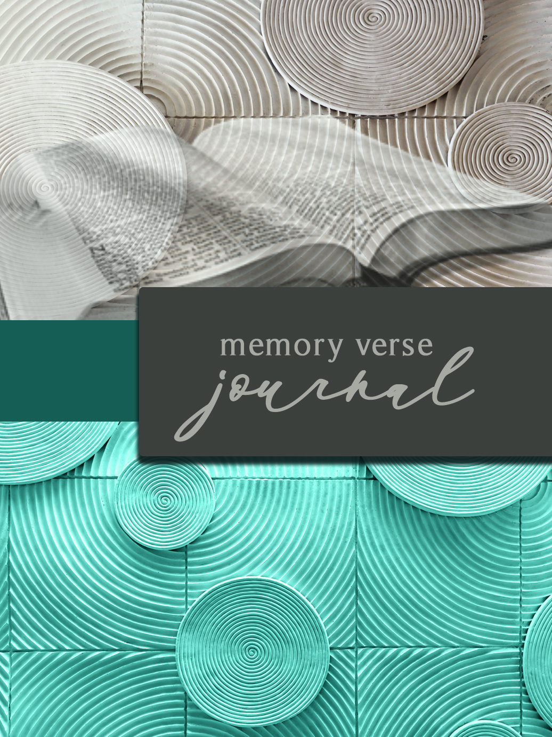
Memory Verse Journal
This edition Oct. 2018

Published by Way of Life Literature
P.O. Box 610368, Port Huron, MI 48061
866-295-4143 (toll free)
fbns@wayoflife.org
http://www.wayoflife.org

Canada: Bethel Baptist Church,
4212 Campbell St. N.,
London, Ont. N6P 1A6
519-652-2619
WEEKLY MEMORY VERSE JOURNAL
INTRODUCTION

“Blessed is the man that walketh not in the counsel of the ungodly, nor standeth in the way of sinners, nor sitteth in the seat of the scornful. But his delight is in the law of the LORD; and in his law doth he meditate day and night. And he shall be like a tree planted by the rivers of water, that bringeth forth his fruit in his season; his leaf also shall not wither; and whatsoever he doeth shall prosper” (Psalm 1:1-3).

If there is one thing we can do to strengthen the churches it is to seriously strengthen the biblical depth of the congregation. “For every one that useth milk is unskilful in the word of righteousness: for he is a babe. But strong meat belongeth to them that are of full age, even those who by reason of use have their senses exercised to discern both good and evil” (Heb. 5:13-14). In my experience and observation, the vast majority of church members even in the most conservative churches are not serious Bible students. They are not skillful in God’s Word and do not have their senses exercised. If the people would become skillful in God’s Word, they would be more spiritually minded, more serious in prayer, more faithful to the house of God, more separated from the evil things of the world, wiser in every aspect of living, wiser in building godly homes and training their children, more zealous for the salvation of souls and the fulfillment of Christ’s Great Commission. The Word of God has the power to do all of this.

The goal of this journal is to help the believer hide God’s Word in his heart (Psalm 119:11) and to meditate on it in an effectual, practical way. God doesn’t want His people to read and memorize the Scriptures in a robotic or parroting fashion. Everything is to be done with understanding. See Psalm 47:7; 1 Corinthians 14:15, 19; Colossians 1:9; 3:16.

Meditating on a verse or passage of God’s Word effectually begins with understanding its meaning. This requires the application of the fundamental principles of Bible interpretation (e.g., context, comparing Scripture with Scripture, defining the words, literal vs. allegorical, understanding figures of speech) and the wise use of Bible study tools (e.g., dictionary, concordance, Treasury of Scripture Knowledge, commentary). A basic education in these things can be obtained from The Effectual Bible Student. This 12-hour video course, accompanied by a printed manual, is available for free viewing and download from www.wayoflife,org. It is also available for purchase on DVDs. The more the child of God invests in pursuing this type of education, the better he will understand the Bible.

Memorization and meditation go together. By memorizing a verse, the believer can then meditate on it as he goes about his daily life. He can ask himself, what does this verse mean? What are its main lessons? What does this mean for my daily life?

The journal is accompanied by a five-year weekly memory verse program (one or two verses per week). The verses are carefully selected for edification and exhortation.

The journal and the weekly memory verse program can be used by individuals, families, classes, and churches.

Whoever is overseeing the memory verse journal program should teach the students to do the following things:

1. Print a copy of the worksheet for each week of the program. We print out 52 copies of the worksheet and bind them together with the introduction and memory verse list. That makes a one-year journal.

2. Each week, the first thing is to write out the memory verse. The act of writing has an important role in memorization.

3. Memorize the verse as quickly as possible, the first day preferably. This is so the student can meditate on it throughout the rest of the week. Memorization and meditation aren’t the same, but they are intimately associated.

4. Use the journal daily, trying to add more answers to the questions. Don’t be content with spending only a few minutes each week answering the questions. The more you put into this, the more you will get out of it.

5. First answer the questions as best as you can on your own. Only after you have done your best should you get ideas from others.

6. After you have tried your best, don’t hesitate to seek help if you don’t understand something. Take the initiative to learn. Don’t be content with not understanding. Be a zealous Bible student, and it will pay great dividends.

7. Get a partner to whom you can repeat your memory verse each week. You can discuss the journal together and learn from one another.

In our church, each week in the main service we have someone read from their journal from the previous week to give the people ideas about how to answer the questions. We choose individuals who are most capable of performing this task. We urge all of the people to bring the journals to the service and jot down new ideas they get from others. Then, as a congregation we repeat together the verse for the coming week several times.

WEEKLY MEMORY VERSE PROGRAM
First Year

Old Testament
Genesis 1:1
Exodus 20:3-4
Deuteronomy 29:29
Psalms 1:1
Psalms 1:2
Psalms 1:3
Joshua 1:8
Psalms 16:11
Psalms 27:14
Psalms 34:19
Psalms 37:4
Psalms 37:23-24
Psalms 37:25
Psalms 119:105
Proverbs 3:5-6
Proverbs 12:24
Isaiah 53:6
Jeremiah 17:9
Daniel 2:21

New Testament
Luke 13:3
Luke 19:10
John 1:9
John 3:3
John 3:16
John 14:6
Acts 4:12
Acts 17:30
Romans 3:10
Romans 3:23
Romans 3:24
Romans 5:12
Romans 6:23
Romans 10:13
Romans 12:1-2
1 Corinthians 4:2
1 Corinthians 6:18
1 Corinthians 15:3-4
1 Corinthians 15:33
2 Corinthians 4:4
2 Corinthians 5:17
Ephesians 2:8-10
Ephesians 4:29
Ephesians 5:11
1 Thessalonians 5:21
2 Timothy 3:15
2 Timothy 3:16-17
Hebrews 10:25
1 Peter 2:2
1 Peter 5:7
1 Peter 5:8
1 John 1:8-9
1 John 2:15-16

WEEKLY MEMORY VERSE PROGRAM
Second Year

Old Testament
Genesis 6:5
Genesis 9:6
Deuteronomy 6:5
Deuteronomy 6:6-7
Deuteronomy 18:10-11
1 Samuel 15:22
1 Samuel 15:23
1 Samuel 16:7
Job 14:1
Psalms 14:1
Psalms 23:1
Psalms 23:2
Psalms 23:3
Psalms 23:4
Psalms 23:5
Psalms 23:6
Proverbs 14:12
Proverbs 14:17
Proverbs 14:23
Proverbs 16:18
Proverbs 19:15
Proverbs 20:1
Proverbs 25:19
Proverbs 31:30
Isaiah 64:6

New Testament
Matthew 4:4
Matthew 6:24
Matthew 7:15
Luke 6:38
John 1:11
John 1:12
John 8:12
John 8:31-32
John 8:47
Acts 1:8
Romans 3:19
Romans 3:20
Romans 13:1
Romans 16:17
1 Corinthians 1:8
1 Corinthians 10:13
1 Corinthians 10:21
1 Corinthians 10:31
2 Corinthians 5:10
2 Corinthians 5:20
2 Corinthians 5:21
Philippians 4:6
1 Thessalonians 5:18
1 Timothy 5:8
2 Timothy 2:22
Hebrews 4:16

WEEKLY MEMORY VERSE PROGRAM
Third Year

Old Testament
Psalms 25:8
Psalms 27:1
Psalms 46:1
Psalms 101:3
Psalms 118:8
Psalms 119:9
Psalms 127:1
Psalms 138:3
Proverbs 1:7
Proverbs 1:10
Proverbs 4:14-15
Proverbs 4:18
Proverbs 4:23
Proverbs 4:24
Proverbs 4:26
Proverbs 5:21
Proverbs 10:17

New Testament
Matthew 5:28
Matthew 6:33
Matthew 7:21-23
Matthew 11:28
Matthew 11:29-30
Matthew 17:21
Mark 7:21-22
Mark 16:15
Luke 10:2
John 1:1
John 1:29
John 17:17
Acts 5:29
Acts 17:11
Romans 1:16
Romans 1:18
Romans 1:20
Romans 2:15
Romans 4:4-5
Romans 10:9
Romans 10:10
Romans 11:6
Romans 11:25
Romans 11:26
Romans 14:23
Philippians 1:6
Hebrews 13:4
James 1:2-3
James 4:4
Hebrews 11:6
1 John 2:4
1 John 5:11
1 John 5:12
1 John 5:13
Jude 24

WEEKLY MEMORY VERSE PROGRAM
Fourth Year

Old Testament
Proverbs 14:15
Proverbs 15:1
Proverbs 15:32
Proverbs 19:27
Proverbs 20:18
Proverbs 22:3
Proverbs 22:6
Proverbs 22:15
Proverbs 28:26
Ecclesiastes 5:3
Ecclesiastes 12:13
Isaiah 7:14
Isaiah 9:6
Isaiah 26:3
Isaiah 40:8
Isaiah 40:31
Isaiah 42:8
Isaiah 44:6
Isaiah 44:22
Isaiah 45:22
Isaiah 48:22
Daniel 2:21
Daniel 2:22

New Testament
John 10:10
Romans 15:4
1 Corinthians 1:10
1 Corinthians 1:30
1 Corinthians 2:14
1 Corinthians 6:19-20
Galatians 1:8
Galatians 2:20
Ephesians 1:3
Ephesians 5:8
Ephesians 5:18
Colossians 3:1
Colossians 3:2
Colossians 3:16
1 Timothy 1:15
1 Timothy 3:15
2 Timothy 2:15
2 Timothy 2:19
Hebrews 1:3
Hebrews 9:27
Hebrews 10:14
James 4:7
James 5:9
1 Peter 1:15
1 Peter 2:11
1 Peter 5:10
2 Peter 1:21
2 Peter 3:9
1 John 4:14

WEEKLY MEMORY VERSE PROGRAM
Fifth Year

Old Testament
2 Chronicles 16:9
Psalms 30:5
Isaiah 55:1
Isaiah 55:8-9
Jeremiah 10:23
Jeremiah 17:5
Jeremiah 17:7
Jeremiah 29:13
Jeremiah 33:3
Lamentations 3:22-23
Ezekiel 18:23
Hosea 3:4-5
Hosea 4:11
Micah 5:2
Nahum 1:7
Habakkuk 2:14
Zechariah 14:9

New Testament
Matthew 24:30
John 15:12
1 Corinthians 15:58
2 Corinthians 6:14
2 Corinthians 9:6
2 Corinthians 9:7
Galatians 3:24
Galatians 3:26
Galatians 5:16
Galatians 5:17
Ephesians 4:22
Ephesians 4:24
Ephesians 4:25
Ephesians 4:28
Ephesians 4:30
Ephesians 4:31
Ephesians 4:32
1 Thessalonians 1:9
1 Thessalonians 1:10
1 Thessalonians 4:3
1 Thessalonians 5:9
1 Thessalonians 5:17
2 Thessalonians 3:3
2 Timothy 2:19
2 Timothy 3:13
2 Timothy 4:3-4
2 Timothy 4:18
Titus 1:16
Titus 3:8
Hebrews 10:19
Hebrews 13:8
Hebrews 13:17
James 1:22
James 2:17
James 5:16
Memory Verse Worksheet (Needed for each verse - 52 copies)

Memory Verse (write it out by hand, using back of the sheet if more space is needed)
_____________________________________________________________
_____________________________________________________________
_____________________________________________________________
What is the main meaning of this verse in your own words?
_____________________________________________________________
_____________________________________________________________
_____________________________________________________________
What are other verses that help me understand this verse? (use the Treasury of Scripture Knowledge)
____________________________________________________________
What are some things this verse teaches me about God?
___________________________________________________________
What sins do this verse reprove?
____________________________________________________________
What are some things this verse teaches me about myself and my daily life?
_____________________________________________________________
_____________________________________________________________
_____________________________________________________________
What are other lessons from this verse?
_____________________________________________________________
_____________________________________________________________
_____________________________________________________________
☐ Memory verse partner heard the verse quoted

